University of Manchester - IDPM

Coffee and Capitalism: Does Fairtrade improve outcomes for developing country producers?
Author: 9483828 Words: 3801 Degree: Development Economics and Policy
Final Mark: 70% (First)

- Introduction
The 1989 Collapse of Coffee Prices provoked mass starvation, fierce violence and vehement protest across the developing world. Whilst consumers were tranquil; relishing in cheaper Coffee across luxury Café’s, landless producers were starving; begging for assistance on unpaved roadsides in Nicaragua. At the same time the Rwandan economy faltered; with many attributing the savage genocide of 1 million to the Economies reliance on Coffee. Clearly the issue of protecting producers is of undisputed importance; with this Fairtrade’s attempted intervention is a highly contentious issue. This paper investigates the role Fairtrade has in improving developing country producer outcomes, offering a review of prominent works when possible. This paper finds that whilst Fairtrade has made remarkable progress in some areas it has its limitations and in some cases has actually made producers worse off. Section 2 gives a background on Fairtrade and coffee, section 3 looks at the positive effects Fairtrade can have whilst section 4 addresses its limitations. This paper concludes with policy recommendations in section 5.
- Background
The ethos of Fairtrade to improve developing country producer outcomes has been present throughout history and its notions can be traced back to the writings of Multatuli’s (1860) “Max Havelaar” which novels the exploitation of Indonesian coffee producers. Modern Fairtrade involves a range of prominent institutions labelling and setting standards for Fairtrade initiatives. Such standards are based on respect, greater equity, sustainable living and better working conditions amongst others (FINE, 2001). To achieve this Fairtrade indoctrinates standards; for example Fairtrade International producers must receive a minimum price for their produce, have equal profit distribution and prohibit child labour.
With the aforementioned standards Fairtrade has become a prominent alternative trade initiative aiming to correct the disparity between international commodity prices and producer wages. Such prominence, backed by rising popularity has seen Fairtrade products become a staple on the household food table, university cafeteria and retailer’s shelf amongst others with UK shoppers alone purchasing £1.7bn worth of Fairtrade products in 2012 (Fairtrade Foundation, 2014). Coffee is one of the most valued and rapidly growing markets with an estimated 1.6 billion cups consumed per day and an estimated market worth of $70.86bn (Euromonitor, 2012). However coffee like many primary commodities is subject to highly unstable prices and a vulnerability to economic shocks. Such is coffees volatility that prices reached a low of $0.43 per pound in 2001 yet escalated to $3.39 per pound in 2010 (Trading Economics, 2015).
- Addressing Fairtrade’s Fans: Where Fairtrade can and has made a positive impact
Given Coffees vulnerability, Fairtrade aims to protect and improve producers with an array of initiatives. One of these initiatives is the minimum price it pays to producers. This minimum price for Fairtrade International stands at $1.40 per pound of unwashed Arabica Coffee meaning producers cannot be paid below this price but are paid above it when the market dictates (Fairtrade international, 2015a).
To demonstrate the effect of minimum pricing Reinecke (2010) compares the market price for coffee to the minimum Fairtrade price between 1989 and 2008 with findings displayed in Figure 1.
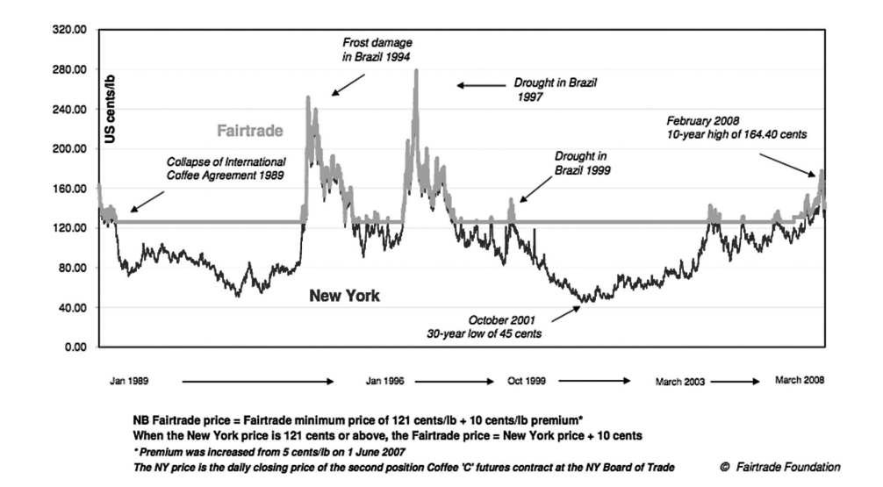
Figure 1

Noticeably there are economic shocks which cause the market price to decline below the Fairtrade minimum price and this occurs for significant periods of time. An implication of minimum pricing therefore is that it can and has sheltered producers from economic shocks. This can drastically improve the outcomes for producers; allowing them to maintain production and offering a stable income in times of economic downturn. An incorrect criticism often levelled with minimum pricing is that producers are not exposed to free market efficiency. In this criticism Fairtrade producers lack incentives to create efficient methods of production and better quality produce (Imhof and Lee, 2007; Sidwell, 2008); this is nullified however by the fact that Fairtrade producers will receive a higher price for higher quality coffee and competition amongst Fairtrade producers is still present. Upon contacting Fairtrade myself they informed me correctly that Fairtrade coffee has won a range of Taste awards which further invalidate quality criticisms (Great Taste Awards, 2014; Fairtrade Foundation, 2015a). Thus minimum pricing shelters producers from negative price shocks without subsidising inefficiencies. This in turn minimises occurrences of mass starvation, homelessness and other adverse features of economic shocks. Minimum pricing has the potential to save a great deal of lives across the developing world. Given some economies are heavily reliant on Coffee exports; Fairtrade can prove pivotal to maintaining economic and political stability.
With the minimum price acting as a security to economic shocks, risk averse producers are more inclined to invest in productivity enhancing capital. This can contest the norm in which investment is too high risk. As an example imagine a producer deciding on whether or not to invest in a coffee harvester; this investment carries a cost which may not be accrued due to exogenous factors such as war. Thus it is not surprising that many producers forego investment. To investigate investment under no minimum pricing Chayanov (1991) interviews Nicaraguan coffee producers and finds that during the 1981 Coffee price collapse; savings was the first income to decline. This was frequently followed by soaring debts. With little income and high debt, desperate producers often on the brink of starvation were forced to use credit for subsistence consumption. With minimum pricing it is possible that Fairtrade prevents such occurrences. Producers know they have a relatively stable income so are more inclined to invest. Savings and therefore investment also do not fall in the case of an economic shock. Finally incidences of high debt in which producers use credit for consumption are minimised, thus credit is released for investment purposes.
Understanding the mechanism in which minimum pricing can incentivise investment, Fairtrade institutions undertook reforms to improve access to credit. This provision was often through Fairtrade buyers who stipulated lending programmes during the pre-harvest in purchase contracts. Beneficially lenient conditions, such as using lower interest rates and providing longer repayment schedules were commonplace (Basu and Hicks, 2008). Fairtrade certification also enabled access to credit amongst international lenders through enhancing the reputability of its producers (Raynolds, 2004). Lenders understood a Fairtrade producer received a stable income in contrast to a non-certified producer whose ability to repay is subject to economic conditions. Improving access to credit can combat the norm across developing countries where credit is often rationed. This is a result of insufficient collateral and an inability of undeveloped capital markets to distinguish between low and high risk borrowers (Stigltiz and Weiss, 1981; Ghosh et al, 1999). De Janvry (2000) further finds evidence that insufficient access to credit has locked Latin American producers into a poverty trap by hindering development into capital intensive production. Evidence generally supports Fairtrade. Mendez et al (2010) surveyed a range of small scale coffee famer households across Latin America and finds Fairtrade certified households have both higher savings (17% compared to 10% in non-certified households) and higher access to credit (43% compared to 34%). Bacon (2008) finds Fairtrade households have higher levels of investment than their non-certified counterparts in Nicaragua. Through surveyed responses he finds 61% of households which joined Fairtrade co-operative unions increased investment with 23% using credit to purchase land. Hence Fairtrade has made remarkable progress in improving access to credit and investment amongst its producers. By providing lenient conditions, low risk borrowers remain in the credit market when credit would have otherwise been rationed. The provision of credit has also complemented offsetting economic shocks thus producers are given the means and the ways to develop capital intensive methods of production. This in turn can unravel the poverty trap.
Whist minimum pricing and access to credit are benefits producers receive; Fairtrade standards which producers must adhere to can also work in their favour. One of these is improved working conditions. These are to prevent the dire conditions producers are subject to across the most impoverished nations, with adult and even child labourers often working in unsafe workplaces, exposed to dangerous chemicals and harassed amongst other adversities.
Of interest within these working conditions is the prohibition on child labour. Here Fairtrade can be applied to theoretical models. Basu and Van’s (1998) model for one implies banning child labour can be welfare worsening as it reduces the household wage. As an example under no child labour ban a household of 2 adults and 6 children could earn $120. Under a ban when only 2 adults work the household wage could decrease to $80. With Fairtrade however this occurrence should not happen; any removal of child labour wages can be offset by the improved income Fairtrade gives to adults. Hence Fairtrade should be welfare improving under its enforced Child labour ban. Kruger et al (2007) models the household’s decision on child labour incidence based on income. Although Fairtrade enforces a ban it is important to investigate the income dynamic as economic incentives are crucial in preventing child labour (Ravillion and Woodon, 2000; Jensen and Nielsen, 1997). Applying the model to Brazilian coffee producer households the model incorporates income effects (increases in household wealth) and substitution effects (increase in the opportunity cost of children’s time). The model suggests increases in income reduce dependence and therefore incidences of child labour. Alternatively exogenous shocks which increase labour demand increase incidences of child labour. To study if Fairtrade has made an impact on child labour Bacon (2008) studies differences in school attendances for producers in Nicaragua. The findings of his study are displayed in Figure 2.
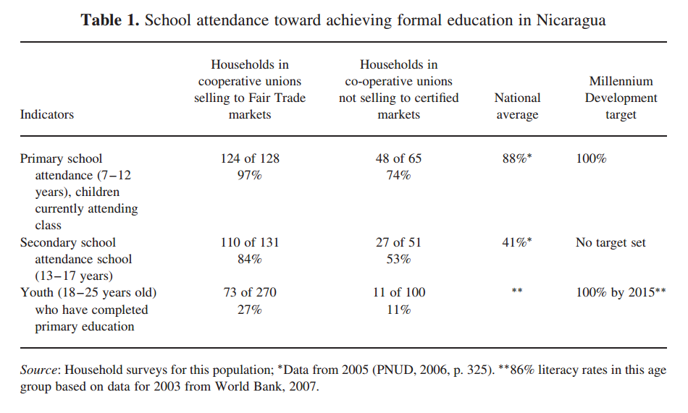
Figure 2
The findings show Fairtrade certified households have higher levels of school attendance across all levels of education than their non-certified counterparts. This is in line with the Kruger model predictions. Hence it is possible that Fairtrade’s improved incomes have caused income effects whilst protecting producers from economic shocks which would cause substitution effects. Both complement each other to reduce child labour further to a prohibition. No conclusive studies on the extent to which this is welfare improving or not are present and an area for further research.
To complement its inhibition on child labour another core value of Fairtrade is improving education. This is to improve the current inadequacy in which producers are often found to have a basic education and speak only their native language (Beuchelt, 2011). In order to improve education, Fairtrade levies a social premium on products (currently $0.20 per pound of coffee) which is used for social programmes such as health, housing and education. For education, the social premium has funded educational facilities, such as renovating secondary schools in Nicaraguan small communities (Utting, 2005) and refurbishing eight schools in Kuapa Kooko a small village in Ghana (Fairtrade Foundation, 2015b). Since these are recent investments studies investigating their effect are rare; however Bacon (2010) attributes the adult illiteracy rate falling from 50% to 20% in Nicaragua to reforms which are influenced by Fairtrade values. Arnould’s (2009) also finds Fairtrade participation is positively and significantly related to income which in turn improves education for Nicaragua, Peru and Guatemala. With no conclusive studies on education a future difference in difference estimation using two samples of the most marginalised producers would be appropriate. In the appendix I attach an outline on how this should be done.
In addition to improved educational facilities, Fairtrade producers gain access to healthcare programmes courtesy of a social premium investment. UCIRI and CEPCO (two Fairtrade producer co-operatives in Mexico) for example fund community health services and medical supplies for its members (Raynolds, 2004). Given the aforementioned arguments one would expect Fairtrade to significantly improve developing country producer health outcomes. The aforementioned Arnould et al (2009) study similarly finds Fairtrade to be significantly and positively related to incomes which in turn is significant in improving health. Further evidence also shows that although Fairtrade participation is not significant with Fairtrade participation in the short term, those who have been Fairtrade certified for over 6 years were found to have significantly improved health outcomes. These findings are unsurprising, Fairtrade investment in health centres, medicines and medical training are long run improvements which need time to take effect. With investments in health centres and medicines, the most impoverished producers are afforded essential medical treatment. Fairtrade therefore can have a significant impact on improving the health of its producers in the short run through improved incomes and in the long run through improved health facilities.
3. Addressing the Critics: Where Fairtrade is Limited
Thus far we have seen how Fairtrade can and have improved producer outcomes. Despite its good intentions however Fairtrade has limitations which prevent the remarkable work it can do and has in some cases actually made producers worse off. This section addresses the limitations of Fairtrade.
- Fairtrade Benefits are Unevenly Distributed
I begin with the criticism levelled at Fairtrade initiative which notes benefits are unequally distributed towards consumer countries through multinational corporations. Fairtrade coffee relies on multinational corporate retailers such as Starbucks for its distribution to the consumer. Such authoritative private companies also have a vested interest in profit maximisation. Thus corporate practices allow such companies to recoup the lion’s share of Fairtrade Coffee. One is through market manipulation; Starbucks frequently send producers order contracts when Coffee prices are at their lowest, allowing them to pay the Fairtrade minimum price floor (Johannessen, 2010). Corporations also have a profound effect on the minimum price itself. In 2006 one of the largest producer co-operatives (CLAC of Latin America) demanded the Fairtrade minimum price should increase. This was based on a need to compensate for inflation and rising producer costs 8 years after Fairtrade was introduced. Fairtrade International thus responded with an independent price review yet this was met with constant impediment as a result of corporate actors. Such actors argued increasing the price would only reduce sales, leading to producers being worse off. Thus a review that began in 2006 was ratified in 2008 and although the minimum price and social premium increased the increase was minimal and not one producer co-operatives were satisfied with (Reinecke, 2010). Evidence generally supports uneven distribution; Johannessen (2010) found only 13.1% of coffee’s value added went to producers in Guatemala; this was in opposition to the 58.2% given to Jon Johannson the Coffee importer. A further study investigating the distribution of each coffee sold on University Cafeterias found only 2.02% of the value went to the producer whilst the large majority went to Sia Café the University retailer. These findings are below in Figure 3.
Figure 3
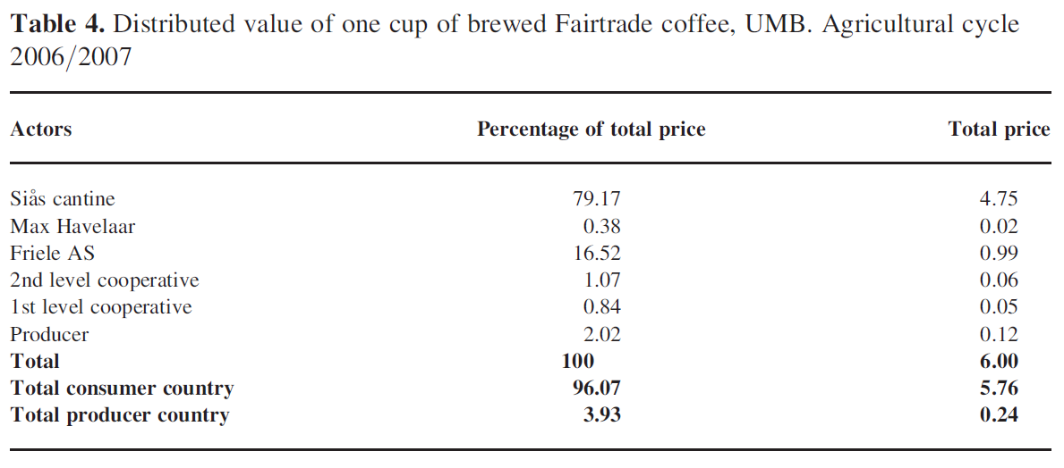
It is an unfortunate occurrence in which Fairtrade must balance providing a minimum price which contributes to the sustainability and development of producers yet does not alienate its consumer country corporate retailers. This battle is often one sided with corporate retailers an overarching presence and poor producers often unable to defend their interests on the world market.
- Fairtrade does not help the Poorest
What should be noticeable throughout this paper is that all studies which support Fairtrade benefits are studies based on middle income countries in Latin America. Fairtrade however has been criticised for doing little if not worsening outcomes for the most impoverished producers. Evidence supports this; Cramer (2014) finds Fairtrade to unambiguously have no positive impact in Uganda and Ethiopia. His findings show wages and working conditions of Fairtrade workers are actually lower than there non-certified counterparts and this is attributed to an improper implementation, evaluation and monitoring of Fairtrade working conditions and wages. Working conditions in Ethiopia between Fairtrade and non are compared in Figure 4 below and it is clear Fairtrade workers are worse off.
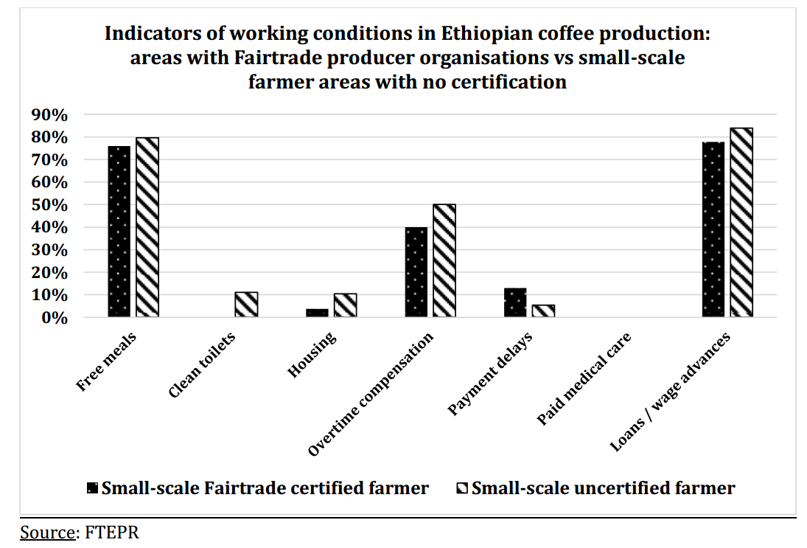
Figure 4
Griffiths (2012; 2009) further argues that Fairtrade has increased production in Latin America which places downward pressure on Coffee prices. This downward pressure has only served to increase infant mortality. Marginalising the poorest is also an inter-country issue. Retailers often buy large quantities of Fairtrade Coffee which only larger co-operatives can produce. Unfortunately small scale producers lack resources to both produce large quantities of Coffee and adhere to Fairtrade standards. For this reason Smith (2007) finds the lion’s share of Fairtrade coffee benefits accrues to larger co-operative producers in comparison to their smaller and poorer counterparts. Due to a range of aforementioned factors Fairtrade is limited in aiding the most impoverished producers. Further to an inability to help the most vulnerable Fairtrade has contributed to exacerbating worldwide and inter-country inequality which has serious percussions for both economic and political stability.
- Fairtrade relies on Country Conditions
Co-Operative debt can seriously hinder the outcomes of Fairtrade producers. In a study of Nicaraguan co-operatives Utting (2005) finds one co-operative may use up to half of the Fairtrade minimum price to pay off debts. In some cases these debts (caused by past coffee price shocks bankrupting producers) have reached substantial levels with one co-operative owing $720,000. This was further exacerbated by institutional factors such as corruption which diverted funds for debt bailouts (Bacon, 2001). Producers also have to pay a range of costs which further decrease their incomes. Talbot (2004) finds the seller pays for transportation costs to the port of shipment; these can be substantial with Johannessen (2010) finding 15% of income is paid for transportation with a further 30% security fee in the case of Nicaraguan co-operatives. Although Fairtrade aims to improve outcomes this can be hindered by factors which are exogenous, factors such as debt and corruption are factors Fairtrade cannot fix and they therefore limit the extent of Fairtrade improvement.
- Fairtrade has done little for the Environment
Given the fact that protecting and sustaining the environment is a core Fairtrade value, consumers would be forgiven for believing remarkable progress is being made through purchases of goods from institutions such as Rainforest Alliance. However research on this area is mixed. Quispe Guanca (2007) finds little improvement in environmental standards after the introduction of Fairtrade in Costa Rica whilst Bitzer (2007) argues small holding coffee producers are unable to implement environmental standards due to a disconnection from NGO’s who favour large scale producers; a finding shared with Giovannucci (2005). Environmental standards however opens up a larger debate within Fairtrade; that of competing Fairtrade institutions. Within this skirmish there are prominent certifications which uphold environmental standards and smaller certifications which attempt to raise environmental standards to further improve environmental outcomes. With market forces favouring the lower cost former and with competition placing pressure on smaller certifications, environmental standards have reached a stalemate with no scope for improvement (Raynolds, 2007). Overall Fairtrade environmental standards are targeted towards large scale producers who are both connected to certifications and have the capacity to adhere to Fairtrade environmental standards. Competition within Fairtrade has also severely limited the standards themselves with prominent institutions setting the norm and smaller certifications unable to raise these norms for fear of being priced out of the market.
- Fairtrade has done little for Gender Equity
Women workers in developing countries are often subject to unequal treatment, discrimination and harassment. Not only do they face unequal non-pecuniary benefits but also receive a significantly smaller wage (Fairtrade USA, 2012; Cramer, 2014). Despite gender equity being a Fairtrade value there is a general urgency that current standards against discrimination and harassment are not enough and although improving these do not improve the status nor empower female Coffee producers (Le Mare, 2008). Lyon et al (2010) investigates gender equity in Mesoamerica and argues that Fairtrade has the potential to boost women’s property rights through increased status but the effect is at a grass roots level only; citing the lack of women membership amongst Fairtrade co-operatives upper hierarchy. This is a finding shared with Taylor (2002) who also argues producers see gender equity as a pressure from Fairtrade institutions and international buyers rather than an enforced law. Poor enforcement and a lack of pressure to raise standards for gender equity have reduced the effectiveness of Fairtrade in this area. Fairtrade does however have the potential however to empower women; for some co-operatives education and training programmes are designed to empower female producers but these are unfortunately focused on commodities outside of Coffee (Murray, 2006).
- Conclusion
This paper investigates the role of Fairtrade in improving developing country producer outcomes; looking precisely at coffee. Fairtrade can and has made remarkable progress in some areas; protecting producers from price shocks, providing the ways and means of investment and improving the often lacking health, education and working conditions of their producers. However it is limited by other factors; corporate actors who depress the essential minimum price, a failure to target the most vulnerable and country conditions such as debt and corruption. Fairtrade has also done little for its core values on environmental sustainability and gender equity. Thus I propose a few recommendations. Fairtrade needs to improve its marketing if it wishes to increase a minimum price. If the average consumer was more aware of Fairtrade’s benefits it would make sense that their willingness to pay (WTP) for Fairtrade coffee would increase. This in turn would boost demand for Fairtrade coffee thus placing upward pressure on its market price and supporting debates into increasing the minimum price. Basu and Hicks (2008) find WTP for Fairtrade coffee follows an inverted U shape with regards to price; hence to maximise profit and benefit prices should be set at the maximisation point. NGO’s and governments have a large role to play in helping the most marginalised producers. Through subsidising certification costs many of the poorest producers can afford Fairtrade certification and the aforementioned benefits it can bring. Fairtrade also needs to do more to target the most vulnerable; introducing a progressive system of certification costs and setting a target on how many producers in absolute poverty should be certified would be ideal. Fairtrade also needs to do more in terms of enforcement and evaluation to help the poorest in sub Saharan Africa. Whilst Fairtrade can do little for corruption and debt it should encourage NGO’s and IGO’s to participate in solving these. Restructuring debt obligation would allow producers to benefit from Fairtrade whilst paying a now more affordable debt. Fairtrade coffee needs to learn from its other commodities on how to improve gender equity as they have complemented anti-discrimination with programmes designed to improve female status. Perhaps providing economic incentives such as increased income per woman on the co-operative membership board would also empower women. In terms of environment if Fairtrade is bound by market forces than it should invest more into environmentally friendly methods of production. Thus waste water facilities, manure management and irrigation are a small number of initiatives for social premium investment. Additionally co-operation between Fairtrade institutions would allow talks into raising environmental standards together. Finally I propose more studies should be done on Fairtrade’s effect on education and child labour’s welfare effect on households. This would decide whether or not Fairtrade is successful in improving education and whether or not its prohibition on child labour is welfare improving or worsening.

References:
Arnould, E. J., Plastina, A., & Ball, D. (2009). Does fair trade deliver on its core value proposition? Effects on income, educational attainment, and health in three countries. Journal of Public Policy & Marketing, 28(2).[Online] Available from: http://digitalcommons.unl.edu/cgi/viewcontent.cgi?article=1011&context=marketingfacpub [Accessed 2nd March 2015]
Bacon.C. (2001). Cupping What You Know: The Story of Nicaragua’s Coffee Improvement Project. [Online] Available from: http://www.agroecology.org/documents/Chris/nica_quality.pdf [Accessed 18th March 2015]
Bacon, C. (2005). Confronting the coffee crisis: can fair trade, organic, and specialty coffees reduce small-scale farmer vulnerability in northern Nicaragua?. World development, 33(3), [Online] Available from: http://ac.els-cdn.com/S0305750X04002062/1-s2.0-S0305750X04002062-main.pdf?_tid=317772f0-cfed-11e4-afb7-00000aab0f01&acdnat=1426958017_da95dbc126b9ea4c4e8b4fe65af306d2 [Accessed 21st March 2015]
Bacon, C. M., Ernesto Mendez, V., Gómez, M. E. F., Stuart, D., & Flores, S. R. D. (2008). Are sustainable coffee certifications enough to secure farmer livelihoods? The millenium development goals and Nicaragua's Fair Trade cooperatives. Globalizations, 5(2). [Online] Available from: https://www.uvm.edu/giee/pubpdfs/Bacon_2008_Globalizations.pdf [Accessed 18th March 2015]
Bacon, C. M. (2010). A spot of coffee in crisis Nicaraguan smallholder cooperatives, fair trade networks, and gendered empowerment. Latin American Perspectives, 37(2), 50-71 [Online] Available from: http://lap.sagepub.com/content/37/2/50.full.pdf [Accessed 10th March 2015]
Baland, J. M., & Robinson, J. A. (2000). Is child labor inefficient?. journal of Political Economy, 108(4), 663-679.
Basu, A. K., and Hicks, R. L. (2008). Label performance and the willingness to pay for Fair Trade coffee: a cross‐national perspective. International Journal of Consumer Studies, 32(5), 470-478. [Online] Available from: http://onlinelibrary.wiley.com/doi/10.1111/j.1470-6431.2008.00715.x/epdf [Accessed 25th March 2015]
Basu, K., & Van, P. H. (1998). The economics of child labor. American economic review, 412-427. [Online] Available from: http://qed.econ.queensu.ca/pub/faculty/sumon/basu_childlabor.pdf [Accessed 17th March 2015]
Beuchelt, T. D., & Zeller, M. (2011). Profits and poverty: Certification's troubled link for Nicaragua's organic and fairtrade coffee producers. Ecological Economics, 70(7). [Online] Available from: http://comerciojusto.org/wp-content/uploads/2013/05/Coffee-profits-poverty.pdf [Accessed 6th March 2015]
Bitzer, V., Francken, M., & Glasbergen, P. (2008). Intersectoral partnerships for a sustainable coffee chain: Really addressing sustainability or just picking (coffee) cherries?. Global Environmental Change. [Online] Available from: http://ac.els-cdn.com/S0959378008000137/1-s2.0-S0959378008000137-main.pdf?_tid=4d697e00-d230-11e4-a24a-00000aab0f02&acdnat=1427206742_47713330e6358272471131344dbee3eb [Accessed 24th March 2015]
Boltanski, L. (2009) De la Critique. Précis de Sociologie de l’Emancipation. Paris: Gallimard (In French).
Chayanov, A.V. (1991). The Theory of Peasant Co-operatives. Ohio State University Press.
Chen, MA. (2000). Women in the Informal Sector: A global Picture, The Global Movement. Radcliffe Institute for Advanced Study. [Online] Available from: http://muse.jhu.edu/journals/sais_review/v021/21.1chen.html [Accessed 11th March 2015]
Chossudovsky, M. (1995). IMF World Bank Policies and the Rwandan Genocide. Global Research. [Online] Available from: http://www.globalresearch.ca/imf-world-bank-policies-and-the-rwandan-genocide/5376752 [Accessed 1st March 2015]
Cramer, C., D. Johnston, C. Oya and J. Sender (2014). Fairtrade, Employment and Poverty Reduction in Ethiopia and Uganda [PDF]. Available from: http://ftepr.org/wp-content/uploads/FTEPR-FinalReport-19-May-2014-FINAL.pdf [Accessed 21st March 2015]
De Janvry, A., & Sadoulet, E. (2000). Rural poverty in Latin America: Determinants and exit paths. Food Policy, 25. [Online] Availble from: http://ac.els-cdn.com/S0306919200000233/1-s2.0-S0306919200000233-main.pdf?_tid=b633074c-d2ff-11e4-aa31-00000aacb35e&acdnat=1427295824_4a2894eef63b02d59b10a9481f4ec18f Accessed 11th March 2015]
Elder, S. D., Zerriffi, H., & Le Billon, P. (2013). Is Fairtrade certification greening agricultural practices? An analysis of Fairtrade environmental standards in Rwanda. Journal of Rural Studies, 32, 264-274.
Euromonitor. (2012). Quoted in “Analysis: Single Cup Coffee sales seen growing. [Online] Available from: http://www.reuters.com/article/2012/02/03/us-coffee-idUSTRE81203720120203 [Accessed 2nd March 2015]
Fairtrade Foundation (2015b). Kuapa Kooko, Ghana. [Online] Available from: http://www.fairtrade.org.uk/en/farmers-and-workers/cocoa/kuapa-kokoo [Accessed 23rd March 2015]
Fairtrade Foundation. (2012). Fairtrade and Coffee, Commodity Briefing. [Online] Available from: http://www.fairtrade.net/fileadmin/user_upload/content/2009/resources/2012_Fairtrade_and_coffee_Briefing.pdf [Accessed 2nd March 2015]
Fairtrade Foundation. (2013). Annual Reports and Financial Statements for the Year Ending 31st December 2013.
Fairtrade Foundation. (2014). Generation Fairtrade: UK Teens want business to act more responsibly. [Online] Available from: http://www.fairtrade.org.uk/en/media-centre/news/october-2014/generation-fairtrade [Accessed 16th March 2013]
Fairtrade Foundation. (2015a). Grumpy Mule (Award Winners). [Online] Available from: http://www.fairtrade.org.uk/en/buying-fairtrade/coffee/grumpy-mule [Accessed 24th March 2015]
Fairtrade International. (2014). Fairtrade Standard for Hired Labour. [Online]. Available from: http://www.fairtrade.net/fileadmin/user_upload/content/2009/standards/documents/2015-01-19_HL_EN.pdf [Accessed 16th March 2015]
Fairtrade International. (2015). Coffee. [Online] Available from: http://www.fairtrade.net/coffee.html [Accessed 6th March 2015]
Fairtrade USA. Why Fair Trade Matters to Working Women Everywhere. [Online] Available from: http://www.triplepundit.com/2012/06/fair-trade-matters-working-women-everywhere/ [Accessed 11th March 2015]
FINE (Through World Fairtrade Organisation). (2001). Definition of Fairtrade. [Online] Available from: http://www.wfto.com/fair-trade/definition-fair-trade
Ghosh, P., Mookherjee, D., & Ray, D. (2000). Credit rationing in developing countries: an overview of the theory. Readings in the theory of economic development, 383-401. [Online] Available from: http://www.nyu.edu/econ/user/debraj/Papers/Gmr.pdf [Accessed 23rd March 2015]
Giovannucci, D., & Ponte, S. (2005). Standards as a new form of social contract? Sustainability initiatives in the coffee industry. Food Policy, 30(3). [Online] Available from: http://ac.els-cdn.com/S030691920500031X/1-s2.0-S030691920500031X-main.pdf?_tid=88458c18-d22f-11e4-a248-00000aab0f02&acdnat=1427206412_7d9c6e5c5a93b29f5a97d909bf3cb88a [Accessed 24th March 2015]
Great Taste Awards. (2014) Winners – Union Hand Roasted Coffee. [Online] Available from: https://www.staffs.ac.uk/assets/harvard_quick_guide_tcm44-47797.pdf [Accessed 24th March 2015]
Griffiths, P. (2012). Ethical objections to Fairtrade. Journal of business ethics,105. [Online]. Available from: http://download.springer.com/static/pdf/665/art%253A10.1007%252Fs10551-011-0972-0.pdf?auth66=1426959171_2b4032882ea30d195e4af8eb52ed58e3&ext=.pdf [Accessed 21st March 2015]
Griffiths, P. (2009). Fairtrade is Not Fair. European Coffee Symposium. Vienna. [Online] Available from: https://www.youtube.com/watch?v=TzzXijnICKY [Accessed 4th March 2015]
Heywood, Colin. (1998). Childhood in Nineteenth-Century France. Work, Health and Education Among the Classes Populaires. Cambridge: Cambridge University Press.
ILO. (2012). Global Employment Trends for Women. [Online] Available from: http://ilo.org/global/research/global-reports/global-employment-trends/WCMS_195447/lang--en/index.htm [Accessed 11th March 2015]
Jensen, P., & Nielsen, H. S. (1997). Child labour or school attendance? Evidence from Zambia. Journal of Population Economics, 10(4), 407-424. [Online] Available from: http://download.springer.com/static/pdf/101/art%253A10.1007%252Fs001480050051.pdf?auth66=1427305950_bcdfcf86b87e6b8e6140f52e4d955f35&ext=.pdf [Accessed 18th March 2015]
Imhof, S., & Lee, A. (2007). Assessing the potential of Fair Trade for poverty reduction and conflict prevention: A case study of Bolivian coffee producers.University of Basel, Switzerland. [Online] Available from: http://www.swisspeace.ch/fileadmin/user_upload/Media/Topics/Further_Topics/Business_and_Peace/Imhof_Sandra_Assessing_the_Potential_of_Fair_Trade_for_Poverty_Reduction_and_Conflict_Prevention.pdf [Accessed 12th March 2015]
Johannessen, S., & Wilhite, H. (2010). Who really benefits from fairtrade? An analysis of value distribution in fairtrade coffee. Globalizations, 7(4), 525-544. [Online] Available from: http://www.tandfonline.com/doi/pdf/10.1080/14747731.2010.505018 [Accessed 15th March 2015]
Kruger, D. I., Soares, R. R., & Berthelon, M. (2007). Household choices of child labor and schooling: A simple model with application to Brazil. [Online] Available from: http://ftp.iza.org/dp2776.pdf [Accessed 17th March 2015]
Le Mare, A. (2008). The impact of fair trade on social and economic development: A review of the literature. Geography Compass, 2(6), 1922-1942. [Online] Available from: http://onlinelibrary.wiley.com/doi/10.1111/j.1749-8198.2008.00171.x/epdf [Accessed 2nd March 2015]
Lyon, S. (2007). Fair Trade coffee and human rights in Guatemala. Journal of Consumer Policy, 30(3), 241-261.
Lyon, S., Bezaury, J. A., & Mutersbaugh, T. (2010). Gender equity in fairtrade–organic coffee producer organizations: Cases from Mesoamerica. Geoforum, 41(1), 93-103. [Online] Available from: http://ac.els-cdn.com/S0016718509000402/1-s2.0-S0016718509000402-main.pdf?_tid=506e9ad6-d302-11e4-9175-00000aacb35e&acdnat=1427296942_7cbfa028519a3757744ee0b581d64b8f [Accessed 13th March 2015]
Marx, K. (1930[1867]) Capital. Trans. from the German Edition by Eden and Cedar Paul. London: J. M. Dent and Sons Ltd
Mendez, V. E., Bacon, C. M., Olson, M., Petchers, S., Herrador, D., Carranza, & Mendoza, A. (2010). Effects of Fair Trade and organic certifications on small-scale coffee farmer households in Central America and Mexico.Renewable Agriculture and Food Systems, 25. [Online] Available from: http://journals.cambridge.org/download.php?file=%2FRAF%2FRAF25_03%2FS1742170510000268a.pdf&code=09c27d5832f8d642ae713db408d36660 [Accessed 15th March 2015]
Multatuli (Dekker, D.E.), Meijer, R.P. and Edwards, R. (1987) Max Havelaar: Or the Coffee Auctions of a Dutch Trading Company (Classics). Penguin Classics Reissue.
Murray, D. L., Raynolds, L. T., & Taylor, P. L. (2006). The future of Fair Trade coffee: dilemmas facing Latin America's small-scale producers. Development in Practice, 16(02), 179-192.
Oxfam International. (2002). Mugged: Poverty in Your coffee Cup. Oxfam International. [Online] Available from: http://www.oxfamamerica.org/static/oa3/files/mugged-full-report.pdf [Accessed 5th March 2015]
Quispe Guanca, J.L., 2007. Caracterización del impacto ambiental y productivo de las Agronómico Tropical de Investigación y Enseñanza (CATIE). (In Spanish). [Online] Available from: http://orton.catie.ac.cr/repdoc/A1725E/A1725E.PDF [Accessed 15th March 2015]
Raynolds, L. T., Murray, D., & Heller, A. (2007). Regulating sustainability in the coffee sector: A comparative analysis of third-party environmental and social certification initiatives. Agriculture and Human Values, 24(2), [Online] Available from: http://download.springer.com/static/pdf/990/art%253A10.1007%252Fs10460-006-9047-8.pdf?auth66=1427207423_19a6d9a9393ce27ad8880eef93ccede9&ext=.pdf [Accessed 24th March 2015]
Raynolds, L. T., Murray, D., & Leigh Taylor, P. (2004). Fair trade coffee: building producer capacity via global networks. Journal of International Development. [Online] Available from: http://onlinelibrary.wiley.com/doi/10.1002/jid.1136/epdf [Accessed 13th March 2015]
Ravallion, M., & Wodon, Q. (2000). Does child labour displace schooling? Evidence on behavioural responses to an enrollment subsidy. The Economic Journal. [Online] Available from: http://onlinelibrary.wiley.com/doi/10.1111/1468-0297.00527/epdf [Accessed 25th March 2015]
Reinecke, J. (2010). Beyond a subjective theory of value and towards a “fair price”: An organisational perspective on Fairtrade minimum price setting. Organisation. Volume 17. [Online] Available from: http://org.sagepub.com/content/17/5/563.full.pdf+html [Accessed 7th March 2015]
Rice, R.A. (2001). Noble Goals and challenging terrain: organic Fair Trade Coffee movements in the global marketplace. Journal of Agricultural and Environmental Ethics. Vol 14.
Ronchi, L. (2002). The impact of Fair Trade on producers and their organizations: A case study with Coocafé in Costa Rica. Policy Research Unit. Sussex: University of Sussex.[Online] Available from: http://www.globalhand.org/system/assets/e74017ed2fbb5c02096f26f3c25faba3ab8e424f/original/The_impact_of_fair_trade_on_producers_and_their_organizations.pdf [Accessed 7th March 2015]
Ruben, R., Fort, R., & Zúñiga-Arias, G. (2009). Measuring the impact of fair trade on development. [Online] Available from: http://www.tandfonline.com/doi/pdf/10.1080/09614520903027049 [Accessed 2nd March 2015]
Ruben, Ruerd and Ricardo Fort. 2012. “The Impact of Fair Trade Certification for Coffee Farmers in Peru,” World Development, 40 (3): 570-582
Saenz-Segura, Fernando and Guillermo Zuniga-Arias. (2009). “Assessment of the Effect of Fair Trade on Smallholder Producers in Costa Rica: A Comparative Study in the Coffee Sector,” Ruerd Ruben (ed), The Impact of Fair Trade, pp. 117-135. Wageningen: Wageningen Academic Publishers
Sidwell, M. (2008) Unfair Trade, Adam Smith Institute, London. [Online]Available from: http://www.adamsmith.org/sites/default/files/images/pdf/unfair_trade.pdf [Accessed 25th March 2015]
Smith, J. (2007) The search for sustainable markets: the promise and failure of fair trade, Culture and Agriculture, 29(2) [Online] Available from: http://onlinelibrary.wiley.com/doi/10.1525/cag.2007.29.2.89/epdf [Accessed 20th March 2015]

Stiglitz, J. E., & Weiss, A. (1981). Credit rationing in markets with imperfect information. The American economic review, 393-410. [Online] Available from: http://www.jstor.org/stable/pdf/1802787.pdf?acceptTC=true [Accessed 15th March 2015]

Talbot, J. M. (2004) Grounds for Agreement: The Political Economy of the Coffee Commodity Chain.

Taylor, P. (2002). Poverty alleviation through participation in Fair Trade coffee networks; synthesis of case study research question findings. Fort Collins, CO: Colorado State University [Online] Available from: http://cfat.colostate.edu/wp-content/uploads/2009/09/Research-Findings.pdf [Accessed 22nd March 2015]
Trading Economics. (2015). Coffee Prices. [Online] Available from: http://www.tradingeconomics.com/commodity/coffee [Accessed 7th March 2015]
Utting-Chamorro, K. (2005). Does fair trade make a difference? The case of small coffee producers in Nicaragua. Development in Practice, 15(3-4), 584-599. [Online] Available from: http://www.jstor.org/stable/pdf/4029988.pdf [Accessed 20th March 2015]
Verwimp, P. (2003). The political economy of coffee, dictatorship, and genocide. European Journal of Political Economy, 19(2), 161-181. [Online] Available from: http://ac.els-cdn.com/S0176268002001660/1-s2.0-S0176268002001660-main.pdf?_tid=f2379796-d31b-11e4-8269-00000aacb35d&acdnat=1427307951_53dc3b13b0ecc10069702fc9b4b93fc2 [Accessed 1st March 2015]
Wilson, B. R. (2010). Indebted to fair trade? Coffee and crisis in Nicaragua.Geoforum, 41(1), 84-92.[Online] Available from: http://ac.els-cdn.com/S0016718509000761/1-s2.0-S0016718509000761-main.pdf?_tid=691588f8-c5b8-11e4-9b7b-00000aab0f6c&acdnat=1425835835_4de53403542640e01867e557c2d82279 [Accessed 8th March 2015]

Appendix:
Outline of Difference in Difference Estimation
This study would involve using two identical coffee producers and estimating the difference between educational outcomes given one producer has Fairtrade certification. For further clarity Box 1 from Ruben et al (2009) outlines the process of such a study:

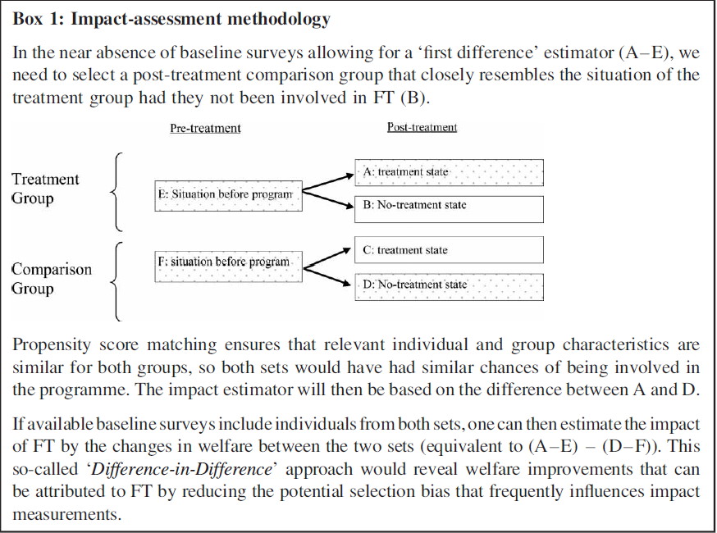
In this case E and F would represent identical coffee producers whilst the treatment is Fairtrade. Since Fairtrade’s educational outcomes are long term effects the treatment state would have to involve at least 8 years (years to complete primary education) of Fairtrade certification. Educational impact could be measured by proxies such as literacy or numeracy rates.
The first difference (A-E) is the difference in educational outcomes between a sample of coffee producers before and after Fairtrade certification. The second difference (D-F) is the difference in educational outcomes between a sample of coffee producers who have not been certified. The “difference in differences” between the two groups allow us to investigate the effects of Fairtrade on educational outcomes. By effectively comparing a Fairtrade group on a non-Fairtrade group holding others factors such as producer characteristics constant.

Email From Fairtrade Regarding Quality:

